Credit Card Fraud Detection
Detecting credit card fraud is a critical application of applied data science. To iovate and improve a credit card fraud detection project, you can follow these steps
- Data Collection:
- Gather comprehensive transaction data, including both legitimate and fraudulent transactions.
- Obtain historical data that represents different patterns of transactions.

2. Data Preprocessing:
- Clean and preprocess the data to handle missing values, outliers, and noise.
- Normalize or standardize features to ensure consistency.

3. Feature Engineering:
- Create relevant features from the data that can help the model differentiate between legitimate and fraudulent transactions.
- Consider using techniques like PCA (Principal Component Analysis) to reduce dimensionality.

4. Data Split:
- Divide the data into training, validation, and test sets to evaluate your model's performance accurately.

5. Model Selection and Development:
- Explore various machine learning algorithms, such as logistic regression, decision trees, random forests, and neural networks.
- Experiment with ensemble methods and deep learning architectures for improved accuracy.

6. Hyperparameter Tuning:
- Fine-tune the hyperparameters of your chosen models to optimize their performance.
- Use techniques like grid search or random search to identify the best hyperparameters.

7. Imbalanced Data Handling:
- Since fraud cases are typically rare, employ techniques like oversampling, undersampling, or synthetic data generation (SMOTE) to address class imbalance.

8. Evaluation Metrics:
- Use appropriate evaluation metrics like precision, recall, F1-score, and AUC-ROC to assess model performance.
- Consider the business impact of false positives and false negatives when setting thresholds.

9. Cross-Validation:
- Implement cross-validation to assess the model's generalization ability and mitigate overfitting.

10. Real-time Monitoring:
- Deploy the model in a real-time environment where it can continuously monitor and detect fraudulent transactions.

11. Anomaly Detection:
- Combine traditional supervised learning with unsupervised anomaly detection methods, such as isolation forests, to identify novel fraud patterns.

12. Explainability:
- Ensure that your model provides interpretable explanations for its predictions, which can be crucial for regulatory compliance and trust.

13. Continuous Learning:
- Continuously update and retrain your model as new data becomes available to adapt to evolving fraud patterns.

14. Collaboration:
- Work closely with domain experts, risk analysts, and fraud investigators to gain insights and improve model accuracy.

15. Security:
- Implement robust security measures to protect sensitive transaction data and the model itself from potential attacks.

16. Regulatory Compliance:
- Ensure that your project complies with relevant data protection and financial industry regulations, such as GDPR and PCI DSS.

17. Documentation:
- Maintain thorough documentation of the project, including data sources, preprocessing steps, model architecture, and results.

18. Ethical Considerations:
- Address ethical concerns related to data privacy and fairness, and implement safeguards against bias and discrimination.

19. Reporting:
- Generate regular reports and alerts for relevant stakeholders, including financial institutions, about detected fraud incidents and model performance.

20. User Education:
- Educate users and customers about best practices for securing their credit cards and recognizing potential fraud.in credit card fraud detection requires a combination of advanced machine learning techniques, domain expertise, and a commitment to staying up-to-date with evolving fraud tactics and data security practices.

Exploratory Analysis
To begin this exploratory analysis, first use matplotlib to import libraries and define functions for plotting the data. Depending on the data, not all plots will be made.

from mpl_toolkits.mplot3d import Axes3D
from sklearn.preprocessing import StandardScaler
import matplotlib.pyplot as plt # plotting
import numpy as np # linear algebra
import os # accessing directory structure
import pandas as pd # data processing, CSV file I/O (e.g. pd.read_csv)

There is 1 csv file in the current version of the dataset:
In [2]:
print(os.listdir('../input'))
['creditcard.csv']
linkcode
The next hidden code cells define functions for plotting data. Click on the "Code" button in the published kernel to reveal the hidden code.

Distribution graphs (histogram/bar graph) of column data
def plotPerColumnDistribution(df, nGraphShown, nGraphPerRow):
nunique = df.nunique()
df = df[[col for col in df if nunique[col] > 1 and nunique[col] < 50]] # For displaying purposes, pick columns that have between 1 and 50 unique values
nRow, nCol = df.shape
columnNames = list(df)
nGraphRow = (nCol + nGraphPerRow - 1) / nGraphPerRow
plt.figure(num = None, figsize = (6 * nGraphPerRow, 8 * nGraphRow), dpi = 80, facecolor = 'w', edgecolor = 'k')
for i in range(min(nCol, nGraphShown)):
plt.subplot(nGraphRow, nGraphPerRow, i + 1)
columnDf = df.iloc[:, i]
if (not np.issubdtype(type(columnDf.iloc[0]), np.number)):
valueCounts = columnDf.value_counts()
valueCounts.plot.bar()
else:
columnDf.hist()
plt.ylabel('counts')
plt.xticks(rotation = 90)
plt.title(f'{columnNames[i]} (column {i})')
plt.tight_layout(pad = 1.0, w_pad = 1.0, h_pad = 1.0)
plt.show()

Correlation matrix
def plotCorrelationMatrix(df, graphWidth):
filename = df.dataframeName
df = df.dropna('columns') # drop columns with NaN
df = df[[col for col in df if df[col].nunique() > 1]] # keep columns where there are more than 1 unique values
if df.shape[1] < 2:
print(f'No correlation plots shown: The number of non-NaN or constant columns ({df.shape[1]}) is less than 2')
return
corr = df.corr()
plt.figure(num=None, figsize=(graphWidth, graphWidth), dpi=80, facecolor='w', edgecolor='k')
corrMat = plt.matshow(corr, fignum = 1)
plt.xticks(range(len(corr.columns)), corr.columns, rotation=90)
plt.yticks(range(len(corr.columns)), corr.columns)
plt.gca().xaxis.tick_bottom()
plt.colorbar(corrMat)
plt.title(f'Correlation Matrix for {filename}', fontsize=15)
plt.show()
# Scatter and density plots
def plotScatterMatrix(df, plotSize, textSize):
df = df.select_dtypes(include =[np.number]) # keep only numerical columns
# Remove rows and columns that would lead to df being singular
df = df.dropna('columns')
df = df[[col for col in df if df[col].nunique() > 1]] # keep columns where there are more than 1 unique values
columnNames = list(df)
if len(columnNames) > 10: # reduce the number of columns for matrix inversion of kernel density plots
columnNames = columnNames[:10]
df = df[columnNames]
ax = pd.plotting.scatter_matrix(df, alpha=0.75, figsize=[plotSize, plotSize], diagonal='kde')
corrs = df.corr().values
for i, j in zip(*plt.np.triu_indices_from(ax, k = 1)):
ax[i, j].annotate('Corr. coef = %.3f' % corrs[i, j], (0.8, 0.2), xycoords='axes fraction', ha='center', va='center', size=textSize)
plt.suptitle('Scatter and Density Plot')
plt.show()

Now you're ready to read in the data and use the plotting functions to visualize the data.

Let's check 1st file: ../input/creditcard.csv
In [6]:
nRowsRead = 1000 # specify 'None' if want to read whole file
# creditcard.csv has 284807 rows in reality, but we are only loading/previewing the first 1000 rows
df1 = pd.read_csv('../input/creditcard.csv', delimiter=',', nrows = nRowsRead)
df1.dataframeName = 'creditcard.csv'
nRow, nCol = df1.shape
print(f'There are {nRow} rows and {nCol} columns')
There are 1000 rows and 31 columns
linkcode
Let's take a quick look at what the data looks like:

df1.head(5) df1.head(5)

https://www.kaggle.com/code/varnika777/starter-credit-card-fraud-detection-2cb0c438-f?scriptVersionId=11343240&cellId=14

Distribution graphs (histogram/bar graph) of sampled columns:
In [8]: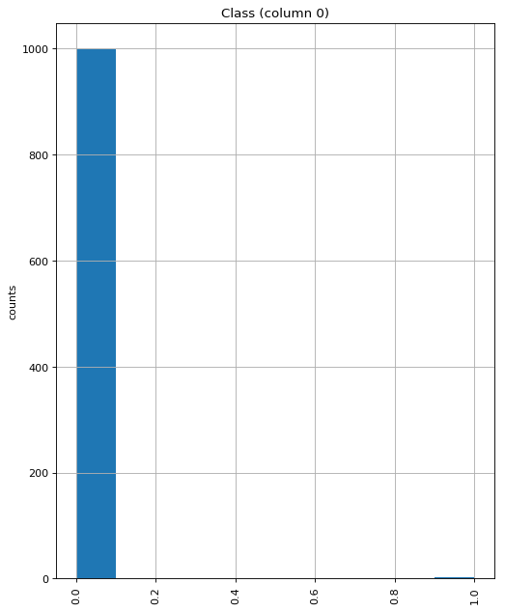

Correlation matrix:
In [9]:
linkcode
plotCorrelationMatrix(df1, 8)
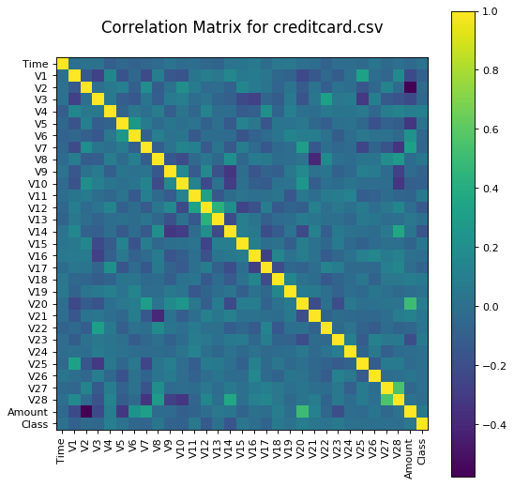

Scatter and density plots:
In [10]:
plotScatterMatrix(df1, 20, 10)

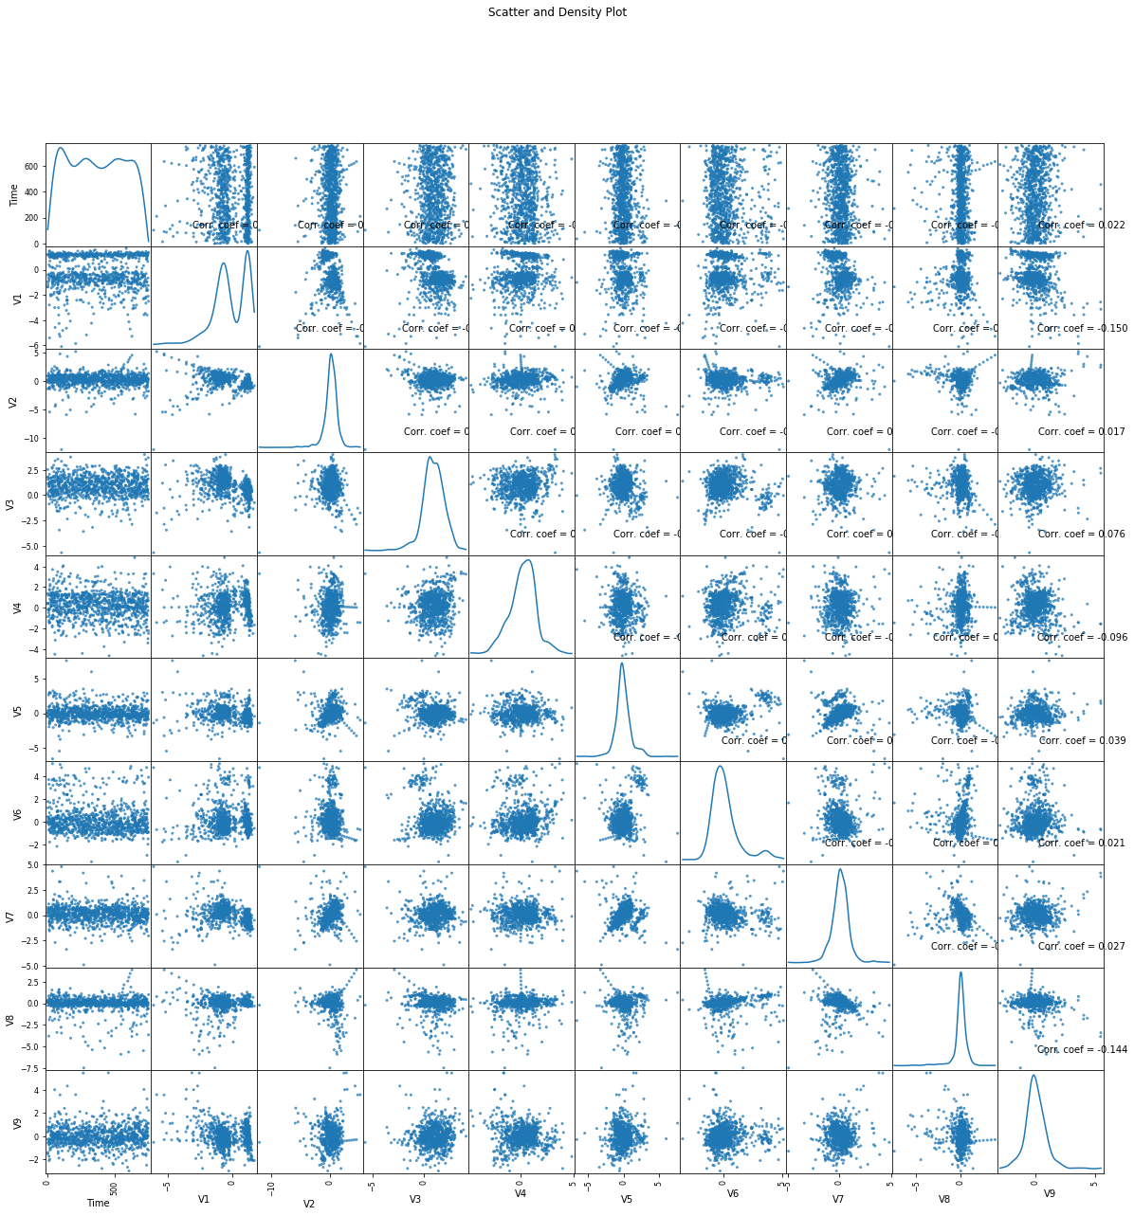

DONE BY:
GUDA OBULA MAHIDAR REDDY
REG NO:720921244019

